**Report: Analyze a Phishing Email Detection**

**Task 2**

Date: [2025-09-22]

Analyst: [Abhijit Chakrabarty]

1) Executive summary

- **Sender:** phishing@pot

- **Subject:** Unusual sign.in activity

- Why suspicious: suspicious URL: [sotrecognizd@gmail.com](mailto:sotrecognizd@gmail.com) redirect this url and Unusual sign.in activity spelling mistake, Generally it’s not appropriate. And the ware forced to click on the link by threatening them.

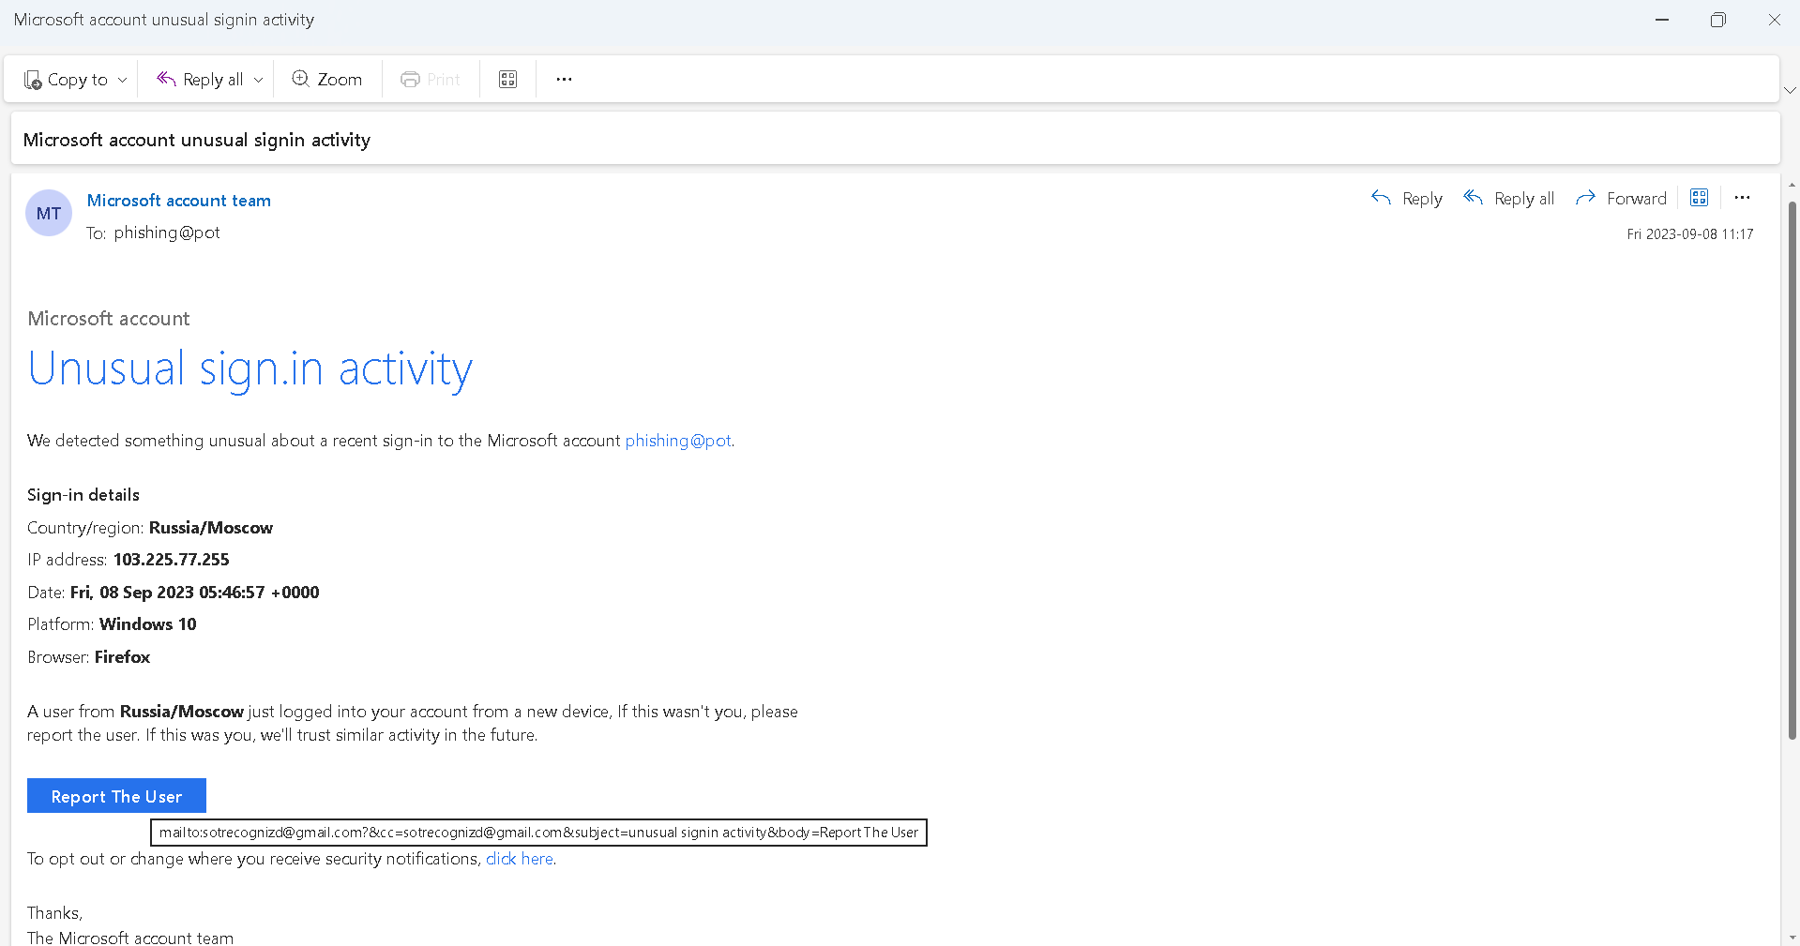

Now the phishing email open with notepad then analysis and get information

* Authentication-Results: spf=none (sender IP is 89.144.44.2)

